Name: | ____________________________________ |  | Date:_________
 | Year 10A Mathematics  $\frac{ }{30}$  Test 1 - 2020  Topic – Similarity and Congruency
Total Time: | 30 minutes
Weighting: | 5%
Equipment: | 1 page of notes (back and front), Calculator, Stationary
Answer all questions in the space provided.
- Which congruence test proves that these two triangles are congruent? [1 Mark]
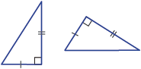

- For the following pair of triangles. [2 marks]
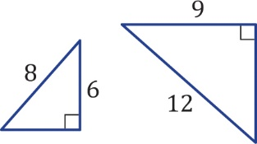

  - Which similarity test proves that they are similar?

  - What is the scale factor of enlargement?

- In this diagram ∠BAD = ∠BCD = 90° and AD = CD.
[4 marks]
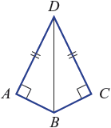
  - Prove ΔABD is congruent to Δ CBD.

  - Hence explain why AB = BC

- Find the values of the pronumerals in the following diagram. Give a reason for your answer.
[3 marks]
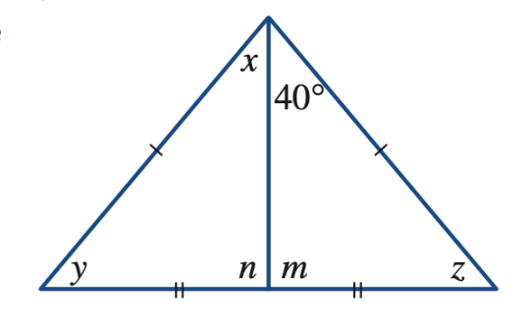

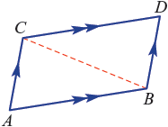
- Consider the parallelogram ABCD
[4 marks]
  - Prove that $∆ACB≡∆BCD.$

  - Hence prove that opposite sides of a parallelogram are equal

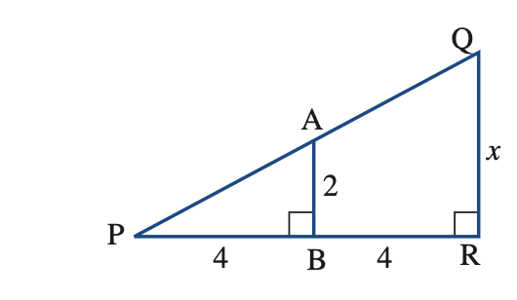
- Given that the triangles below are similar. Find the value of $x$. [2 Marks]

- Prove that in the diagram below ΔAZQ is similar to ΔYZB and find the value of$a$

- Malcolm can see a tree on the opposite bank of a river. He decides to place rocks (indicated with dots) on his side of the river to try to calculate the river’s width. He measures the distances between some pairs of rocks and finds that BC = 25 m, CD = 10 m and DE = 8 m, as shown in the diagram below.
[4 marks]
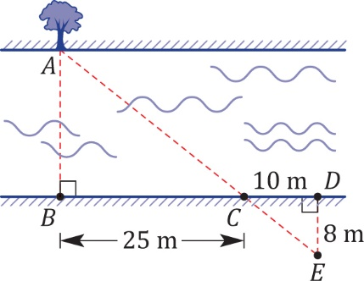

- Show that Malcolm has formed a pair of similar triangles by proving ΔABC $∼$ ΔEDC.

- Hence find the width of the river by calculating the distance AB.

